

Project Title
AI-Driven Growth and Efficiency Transformation (AIGET)
EMAIL FILTERING AI AGENT PROJECT REPORT

Team Members | Supervisors
Sameer Basnet | Sunil Wadhwani
Shivangi Anilbhai Kakadiya | Naveen Kumar
Susmita Khadka | Visweswaran Soundararajan
Touhidul Islam | Goutham Goraka

Table of Contents
1. Executive Summary 2
2. Agenda and Purpose of the Project 2
3. Step-by-Step Process 2
4. Project Timeline 3
5. Technologies, Tools, and Languages Used 3
6. Permissions Required 4
7. Updates & Change Management 4
8. Best Practices & Maintenance 5
9. Sharing & Versioning 5
10. Dataset and Class Distribution 5
11. System Features and Capabilities 6
12. Key Lessons & Next Steps 7
13. Future Recommendations 8
14. Planned Work (Weeks 7–12) 9
15. Figures and Tables 9
16. Conclusion 11

1. Executive Summary
The project provides a Python based, in-house AI agent that can predict the type of email with a high degree of accuracy based on raw text. It is a combination of current NLP libraries (Transformers, PyTorch), has feature-accessible web service (FastAPI) and is designed to be extended in the future to add seamless mailbox filtering in Outlook or other mail systems. By the end of week 6, every fundamental automation, machine learning, and API functionality should be completed, albeit.

2. Agenda and Purpose of the Project
The purpose of this project is to design and deploy an AI-based system that will automatically categorize company emails into business-related types (such as an alert, invoice, phishing, etc.) and allow business processes to be automated without issues and the system to improve cybersecurity positions.
The agenda of this project includes:
- Understanding the business requirements and email types relevant to Jypra Group.
- Collecting and labeling real company emails to create a training dataset.
- Creating, training, and implementing a machine learning model to classify email.
- Exposing model functionality through REST API for testing and future integration.
- Optimally enhancing system usability and model accuracy in a 12 week schedule.

3. Step-by-Step Process
Email Category Classification System
Below is a clear, step-by-step outline explaining how your new machine learning model and web app work for processing and classifying Outlook emails (in .msg or .zip format). This is perfect for your documentation or onboarding future users!
1. Prepare and Train the Model
Collect Training Data:
Gather a clean spreadsheet (test1.csv) where each row contains columns for filename, sender, domain, subject, predicted_category, and reasoning based on real company emails.
Combine Key Features:
Concatenate important columns (like sender, domain, subject, and reasoning) into a single text string that best represents each email for learning.

Train the Classifier:
Load the combined feature as input and predicted_category as the target label.
Train a text classification model (such as TfidfVectorizer + Naive Bayes) on this data.
Save the trained model for later use by the web app.
2. Set Up the Web Application
User Interface:
Provide a web page where users can upload .msg files (single Outlook emails) or .zip archives containing multiple .msg files.
Disallow other file types for bulk uploads—only native Outlook message files (.msg) or zipped collections are accepted.
Category Management:
Users can manage (add, edit, delete) categories through a user-friendly, no-code interface.
3. Processing Incoming Bulk Emails
File Handling:
On bulk upload, the web app checks the file type uploaded.
If a single .msg file: directly read and process it.
If a .zip file: open it and extract all contained .msg files.
For each .msg email:
Parse out the sender, domain, subject, and (optionally) additional details.
Feature Construction:
Combine the extracted fields in the same way as during training (e.g., sender + domain + subject + reasoning).
4. Prediction & Output Table
Model Prediction:
Feed the combined text from each email to the trained ML model.
The model predicts the most likely category for each email.
Result Display:
After processing all emails, the app displays the results in a table, showing:
Filename
Sender
Domain
Subject
Predicted category (from the ML model)
Reasoning (left blank or generated, as applicable)
Download/Copy:
Users can view, copy, or analyze the output table—all columns match your new, clean data structure.
5. Retraining and Maintenance
When new labeled emails are available, update test1.csv and retrain the model using the latest data.
The system remains in sync: the way features are extracted during upload/testing always matches the way the model was trained.
This workflow ensures your AI agent always processes, classifies, and manages emails in the same consistent way—using only Outlook .msg files or zipped collections, with an output table that mirrors your improved dataset format.
Step-by-Step Usage in Visual Studio Code
1. Open Your Project Folder in VS Code
Make sure your folder contains:
app.py (Flask web server)
train_model.py (script to train your model)
test1.csv (your latest training data)
email_classifier.pkl (the model file, after training)
The /templates folder with index.html, result.html
Requirements: extract_msg, flask, pandas, scikit-learn, joblib
The folder structure should look like this.
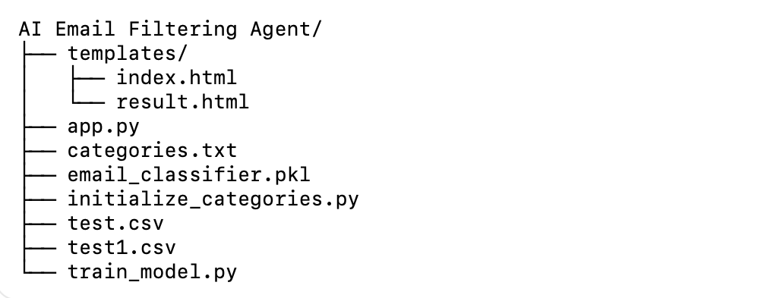
2. Install Required Libraries
In the VS Code integrated terminal, run:
bash
pip install flask pandas scikit-learn joblib extract-msg
3. Train the Model (Whenever Data Changes)
Every time you update or replace test1.csv, run:
bash
python train_model.py
This updates email_classifier.pkl with the latest training data.
4. Start the Flask Web Server
Run in the VS Code terminal:
bash
python app.py
You should see output like:
“Running on http://127.0.0.1:5000/ (Press CTRL+C to quit)”
5. Access the Application in Your Browser
Open Google Chrome or your preferred browser.
Enter this URL in the address bar:
text
http://127.0.0.1:5000/
This will load your Email Category Processor dashboard/webpage.
6. Upload and Classify Emails
Only upload .msg files (Outlook items) or a .zip containing multiple .msg files.
Use the "Bulk Email" upload section on the web page.
Click "Classify Bulk Emails" to process.
7. View Results
After uploading, you’ll see a table with:
filename, sender, domain, subject, predicted category, and reasoning.
For single .msg files:
They are processed one at a time and displayed instantly.
For .zip files:
All included emails are processed together, and results shown in a table.
8. Category Management (if included in your UI)
Use the Add/Edit/Delete category features on the dashboard if needed.
9. Stopping the App
Go back to VS Code terminal and press Ctrl+C to stop the Flask app.

4. Project Timeline
Total duration: 12 weeks (Week 1: Aug 11 – Week 12: Oct 31)
Weeks | Key Project Milestone/Activity
1–2 | Project design, requirements gathering, tool/software selection, initial dataset assembly
3–4 | Data cleaning, manual labeling, development of initial CSV/email corpus
5 | First model training, transformer fine-tuning, and validation on email data
6 | FastAPI server development, API deployment, and script-based and web-based testing
7–8 | Large-scale batch validation, error analysis, and data augmentation
9 | Model retraining with expanded data, improved validation and monitoring routines
10 | User acceptance testing, feedback collection from business teams
11 | Outlook integration (pending IT/app permissions), security, and usability refinements
12 | Final documentation, reporting, project review, and handover for production rollout

5. Technologies, Tools, and Languages Used
Tool/Platform | Purpose | Example/Link
Python 3.x | Main project language | https://python.org
PyTorch | Deep learning library for model training | https://pytorch.org
HuggingFace | Transformers/model management | https://huggingface.co
FastAPI | API framework | https://fastapi.tiangolo.com
OpenAI API | LLM | https://platform.openai.com/
Uvicorn | API server runner | https://www.uvicorn.org
Microsoft Graph | (Planned) Outlook/Office 365 mailbox integration | https://learn.microsoft.com/graph
O365, imaplib | (Alternate) Reading emails from Outlook or IMAP | https://pypi.org/project/O365/
Swagger UI | Built-in API docs and testing | /docs endpoint in FastAPI
CSV/Excel | Data storage for emails and class labels | Microsoft Excel, LibreOffice
VS Code/Editors | Development | https://code.visualstudio.com/
PowerShell/cmd | Scripting, automation, file operations | Windows built-in tools

6. Permissions Required
- For mailbox integration (future):
  - Azure App Registration (for Microsoft Graph):
    - Mail.Read, Mail.ReadWrite, User.Read, offline_access
  - Admin consent may be required to enable app access for company mailboxes
- For scripts/execution:
  - OS-level ability to run python scripts
  - File/folder read/write for CSV and model files

7. Updates & Change Management
- Every time code, data, or configuration changes, update the documentation immediately.
- Use clear “Changelog” entries to log what’s changed.
- Store the latest document in a known, access-controlled company location (Onedrive).
- Share the updated document link with the team and stakeholders.

8. Best Practices & Maintenance
- Scheduled Model Retraining: Retrain the model quarterly with newly labelled emails to prevent performance decline and adapt to evolving data (Brownlee, 2020).
- Security Patching: Regularly update libraries such as PyTorch, HuggingFace Transformers, and FastAPI to minimise vulnerabilities.
- User Training: Provide ongoing training for staff on interpreting classification outputs, understanding confidence scores, and handling misclassifications.
- Monitoring and Logging: Implement dashboards and review logs weekly to detect anomalies and track system performance.
- Backup and Recovery: Maintain backups of datasets, trained models, and configurations to allow quick recovery during failures.

9. Sharing & Versioning
- Keep the document in some common place on the web, with version history or/and logs of commit.
- Every new release must contain some timestamp and change notes.
- Always inform the team with the newest connection whenever a change has been made.

10. Dataset and Class Distribution
Metric | Value
Emails (current) | 55
Classes | 15
Format | CSV
Class Frequencies (Top):
Label | Examples
alert | 8
purchase_order | 7
vendor_communications | 7
invoice | 6
vendor_support | 6
newsletters | 5
client_communication | 5
(others, each ≤4) | ...

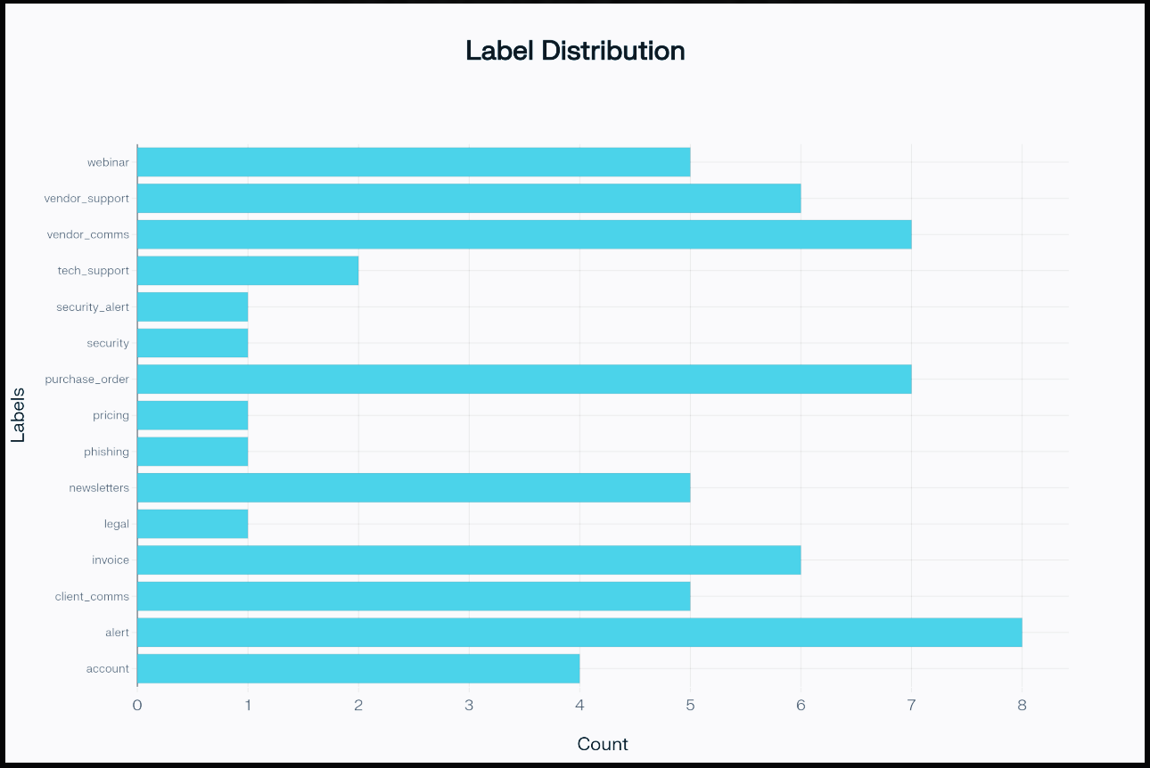
Fig.1. Label Distribution

11. System Features and Capabilities
Feature | Description
Email text classification | Predicts business category label from email subject/body
Confidence estimation | Returns a prediction confidence/probability for each label
RESTful API | Exposes classification as a /predict endpoint for integration/testing
Test automation | Scriptable for batch runs on exported or pasted emails
Planned mailbox automation | Designed for future full integration with Outlook or similar via Python/Graph API
Modular/extensible code | Easy to retrain, update, and improve on latest data

Example API Request/Response
json
POST /predict
{
"text": "Invoice attached for purchase order 2781..."
}

→ Response:
{
"label": "invoice",
"confidence": 0.93,
"class_id": 3
}

12. Key Lessons & Next Steps
- Imbalance in Labels: Some of the categories have small examples (legal, phishing, security_alert), potentially lowering the reliability of the classification to such cases.
- Data Quality: Continuous updating and relabelling, as well as adding underrepresented classes, will help increase the level of accuracy.
- API Integration: API will enable an easy integration with internal or external mail system to process email fully automated and hands free.
- Scalability: Workflow allows supporting new categories and connecting with other business systems (ERP, ticketing, etc.) when the requirements change.
- Team Collaboration: Dividing tasks across model training, API development, and documentation improved productivity and encouraged knowledge sharing.
- Data Imbalance Challenge: Limited samples in categories such as phishing and legal emails highlighted the need for dataset expansion and balancing to improve reliability (Sun et al., 2009).
- API Usability: Early testing using Swagger UI identified usability issues and allowed refinement of endpoints for smoother user experience.
Next Steps:
- Expand dataset with at least 200–300 emails per class.
- Build automated retraining pipelines with version control.
- Conduct pilot testing with business teams to validate real-world usability.

12.1 Limitations
While the project successfully demonstrated the feasibility of AI-driven email classification, several limitations were identified. Firstly, the dataset used was relatively small and imbalanced, with certain classes such as phishing and legal correspondence underrepresented. This limited the model’s ability to generalise effectively across all categories .Secondly, the system currently supports only English-language emails, restricting its applicability in multilingual business environments.
Another limitation lies in explain ability. Although the model can provide confidence scores, it does not yet offer insights into why a particular classification was made. This reduces user trust and transparency .Finally, the prototype has not undergone large-scale performance testing under high-volume email inflows, meaning scalability and robustness under enterprise-level workloads remain unverified. Addressing these limitations will be critical for the system’s long-term success and enterprise adoption.

13. Future Recommendations
- Add hundreds of new examples per label, particularly poorly represented ones.
- Retrain the model, test on actual incoming mail, and refine label set and class boundaries.
- Develop API integration scripts to have a complete automation of the mail intake (Outlook) to have an end-to-end automation.
- Observation and correction of new business processes needs of new class labels or smarter routing logic.
- Miscategorized or unclear emails can also be collected and used to further improve classification logic.
- Extend the system to classify emails in multiple languages to support global clients and multicultural workplaces.
- Incorporate explainable AI techniques (e.g., SHAP, LIME) to help users understand classification decisions, improving transparency and trust.
- Implement semi-supervised or active learning, allowing the model to request user feedback on uncertain emails to continuously improve performance.
- Develop a monitoring dashboard to track email inflow, classification accuracy, and retraining needs in real time.
- Regularly review the system against data privacy laws (GDPR, Australian Privacy Act) and ethical AI guidelines to ensure responsible deployment (OAIC, 2023).

14. Planned Work (Weeks 10–12)
Week Range | Planned Actions/Deliverables
7–8 | Expand labeled dataset, add data to rare categories for improved robustness
9 | Retrain model, validate on an expanded and balanced email set
10 | User acceptance testing (wider user feedback), model fine-tuning
11 | Begin mailbox and workflow integration (pending access), implement secure endpoints
12 | Produce final report, deployment guide, and present results to company stakeholders

15. Figures and Tables
i. Figure 1: System Workflow
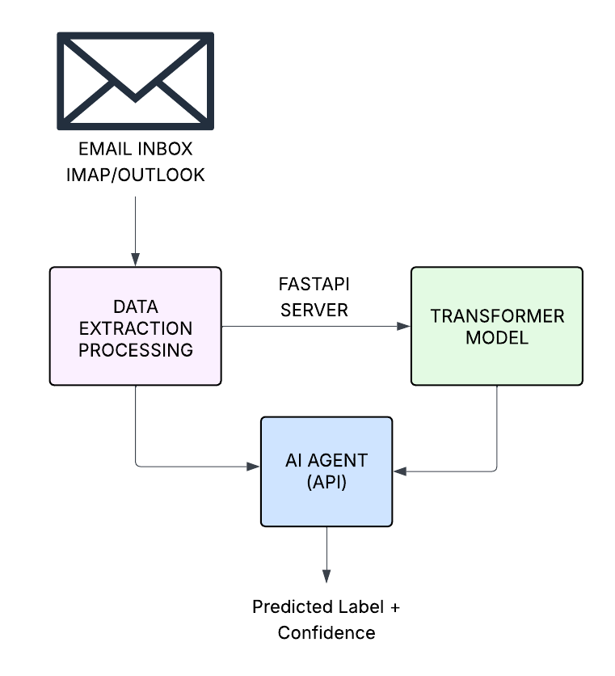
Fig.2. System software architecture

iii. Figure 2: Flowchart
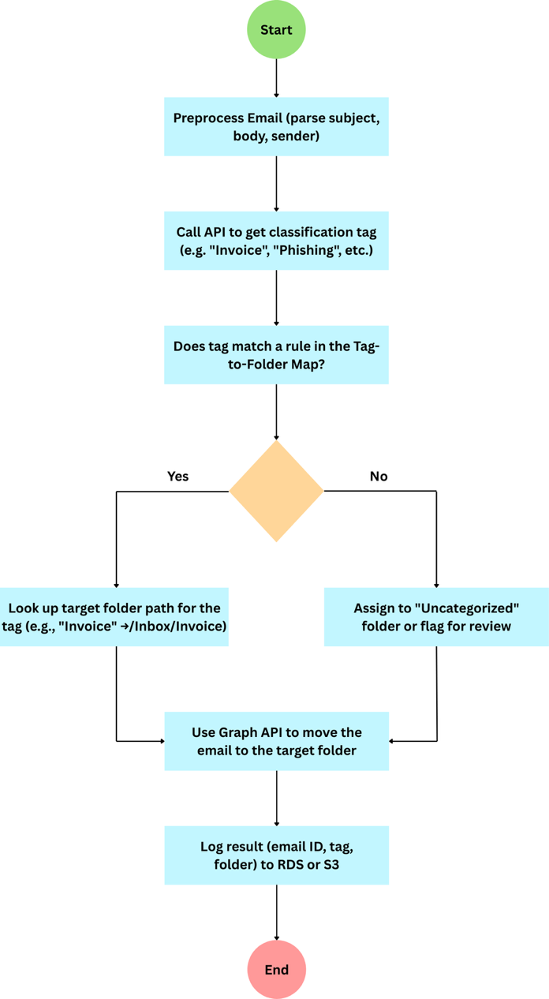
Fig.3. Flowchart Diagram
ii. Table: Weekly Timeline at a Glance
Week | Milestone
1-2 | Requirements, tools, initial data
3-4 | Data cleaning/labeling
5 | Model train/validate
6 | API dev, testing, reporting
7-8 | Data expansion, analysis
9 | Retraining, validation
10 | User testing, feedback
11 | Integration, security hardening
12 | Handover/report/presentation

iii. API Interface
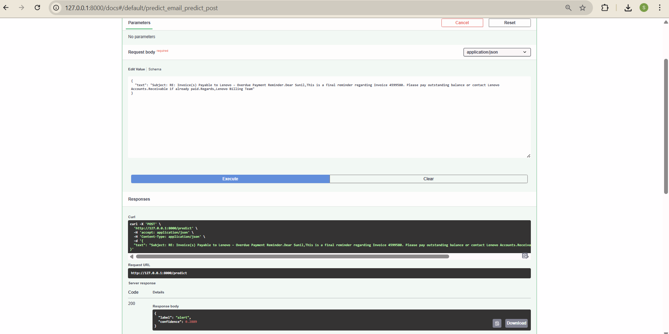

16. Conclusion
This project has been able to establish a feasible AI-based email classification base with solid Python frameworks, current machine learning algorithms, and workable interfaces to integrate. As more data are enriched and mailbox automation is achieved, it is possible to create real-time business value by automating routine triage, enhancing response time, and minimizing operational risk using this platform.

References:
- Brownlee, J., 2016. Machine learning mastery with Python: understand your data, create accurate models, and work projects end-to-end. Machine Learning Mastery.
- Putta, P., Mills, E., Garg, N., Motwani, S., Finn, C., Garg, D. and Rafailov, R., 2024. Agent q: Advanced reasoning and learning for autonomous ai agents. arXiv preprint arXiv:2408.07199.https://arxiv.org/abs/2408.07199
- Hadfield, G.K. and Koh, A., 2025. An economy of AI agents. arXiv preprint arXiv:2509.01063.https://arxiv.org/abs/2509.01063
- Lazzari, L., Mari, M. and Poggi, A., 2005, September. A collaborative and multi-agent approach to e-mail filtering. In IEEE/WIC/ACM International Conference on Intelligent Agent Technology (pp. 238-241). IEEE. https://ieeexplore.ieee.org/abstract/document/1565543
- Lutz, E., Kleist-Retzow, H.V. and Hoernig, K., 1990. MAFIA—An active mail-filter-agent for an intelligent document processing support. ACM SIGOIS Bulletin, 11(4), pp.16-32. https://dl.acm.org/doi/abs/10.1145/122220.122222
- Garfinkel, S.L. and Grunspan, R.H., 2019. The computer book: From the abacus to artificial intelligence, 250 milestones in the history of computer science. Union Square & Company.
- Siebach, J.A.J., 2021. The Abacus: A New Approach to Authorization (Master's thesis, Brigham Young University). https://www.proquest.com/openview/cc899a86321d4ea2a57b8cea26e6c113/1?pq-origsite=gscholar&cbl=18750&diss=y

